**1 Introduction**

* 1. Overview
  2. Purpose

1. **Problem Definition and Design Thinking**
   1. Objective
   2. Ideation and brainstorming
2. **Result and discussions**
3. **Advantages and disadvantages**
4. **Application**

**INTRODUCTION**

* 1. **Overview:**

A digital twin is a virtual model designed to accurately reflect a physical object. The object being studied—for example, a wind turbine—is outfitted with various sensors related to vital areas of functionality. These sensors produce data about different aspects of the physical object’s performance, such as energy output, temperature, weather conditions and more. This data is then relayed to a processing system and applied to the digital copy.

Once informed with such data, the virtual model can be used to run simulations, study performance issues and generate possible improvements, all with the goal of generating valuable insights—which can then be applied back to the original physical object.

Although simulations and digital twins both utilize digital models to replicate a system’s various processes, a digital twin is actually a virtual environment, which makes it considerably richer for study. The difference between digital twin and simulation is largely a matter of scale: While a simulation typically studies one particular process, a digital twin can itself run any number of useful simulations in order to study multiple processes.

The differences don’t end there. For example, simulations usually don’t benefit from having real-time data. But digital twins are designed around a two-way flow of information that first occurs when object sensors provide relevant data to the system processor and then happens again when insights created by the processor are shared back with the original source object.

By having better and constantly updated data related to a wide range of areas, combined with the added computing power that accompanies a virtual environment, digital twins are able to study more issues from far more vantage points than standard simulations can—with greater ultimate potential to improve products and processes.

here are various types of digital twins depending on the level of product magnification. The biggest difference between these twins is the area of application. It is common to have different types of digital twins co-exist within a system or process.

* 1. **Purpose:**

Digital twins are used across the whole manufacturing lifecycle, from designing and planning to maintaining existing facilities. A digital twin prototype allows you to monitor your equipment at all times and analyze performance data that shows how a particular part or the entirety of your plant is functioning.

A Process Flow Diagram has multiple purposes: To document a process for better understanding, quality control and training of employees. To standardize a process for optimal efficiency and repeatability. To study a process for efficiency and improvement.

piping and instrumentation diagram (P&ID) is defined as follows: A diagram which shows the interconnection of process equipment and the instrumentation used to control the process. In the process industry, a standard set of symbols is used to prepare drawings of processes.

P&IDs are a schematic illustration of the functional relationship of piping, instrumentation and system equipment components used in the field of instrumentation and control or automation. They are typically created by engineers who are designing a manufacturing process for a physical plant.

These facilities usually require complex chemical or mechanical steps that are mapped out with P&IDs to construct a plant and also to maintain plant safety as a reference for Process Safety Information (PSI) in Process Safety Management (PSM). If something does go wrong, reviewing the P&ID is usually a good place to start. P&IDs are invaluable documents to keep on hand, whether they’re used to streamline an existing process, replace a piece of equipment, or guide the design and implementation of a new facility. With the record they provide, changes can be planned safely and effectively using Management of Change (MOC).

**2 PROBLEM DEFINITION AND DESIGN THINKING**

**2.1:Objective:**

To get the more knowledge in the creation of Process Flow Diagram and Piping and Instrumentation Diagram of an process station to know the valve of using the COMOS are understand.

**2.2: Ideation and brainstorming:**

**PROCESS FLOW DIAGRAMS:**

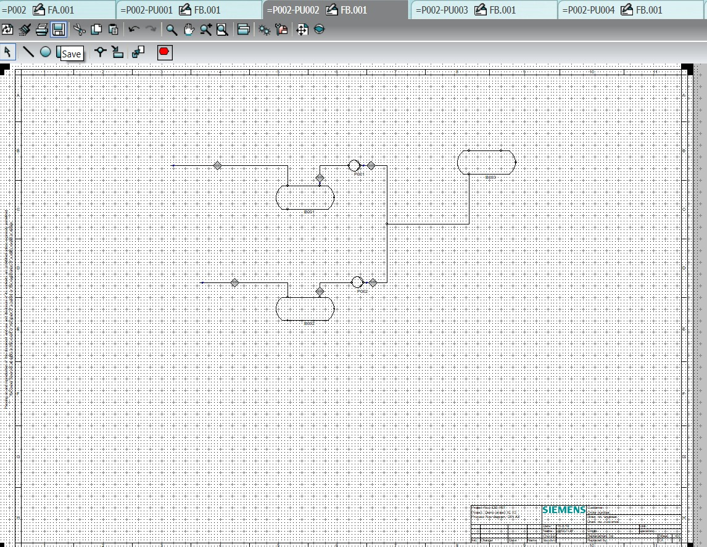

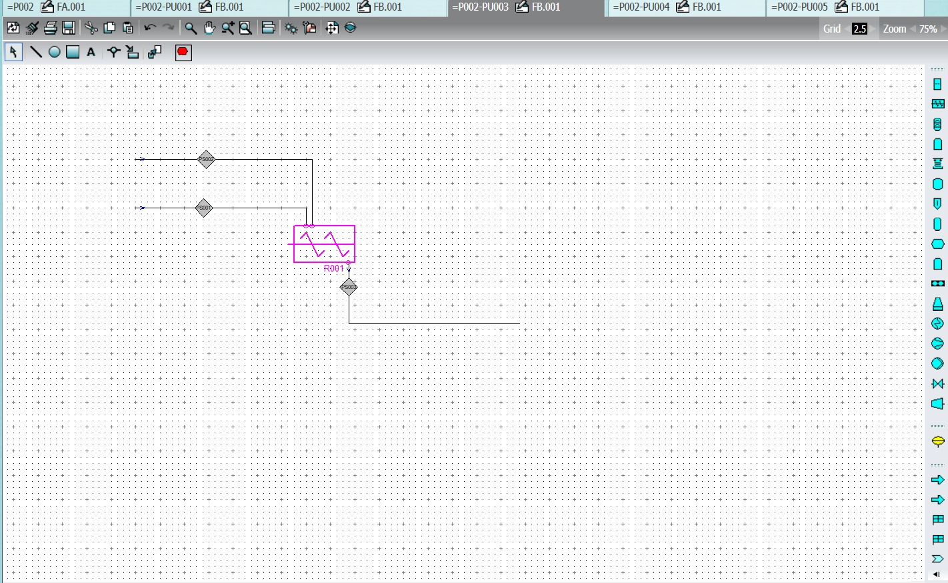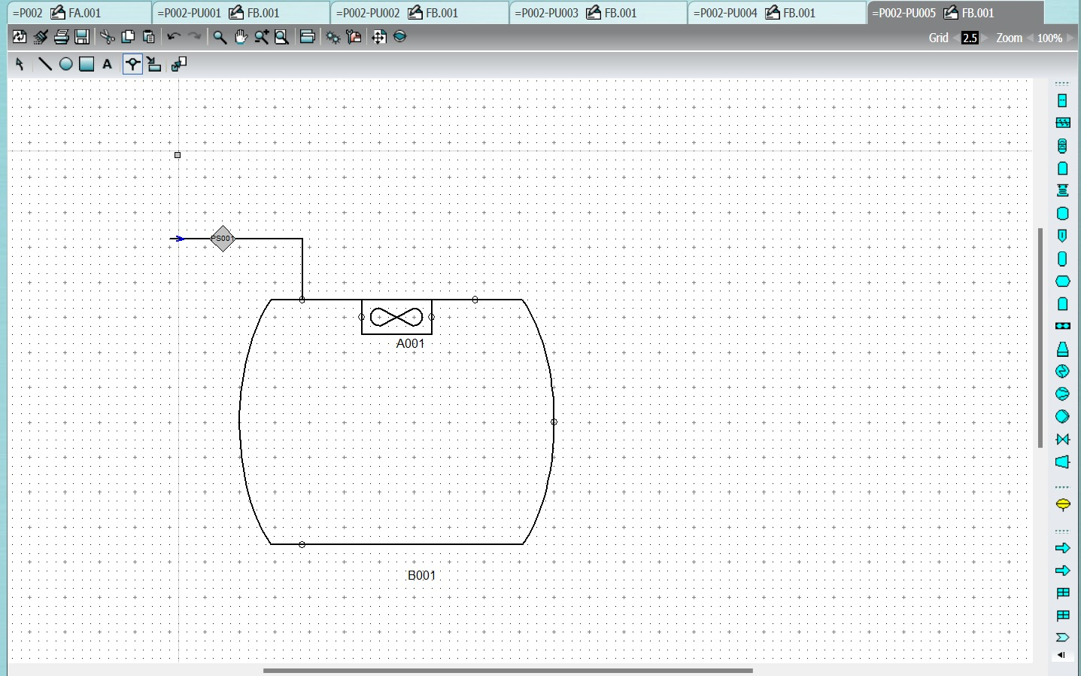

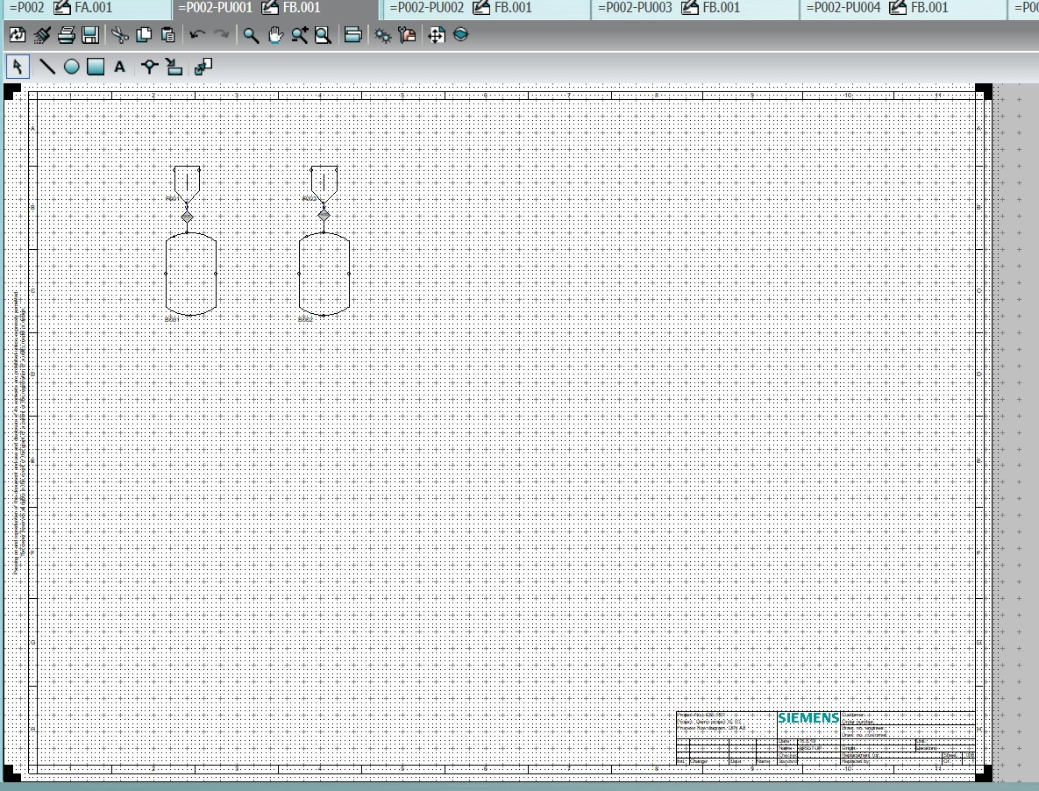

**PIPING AND INSTRUMENTATION DIAGRAM:**

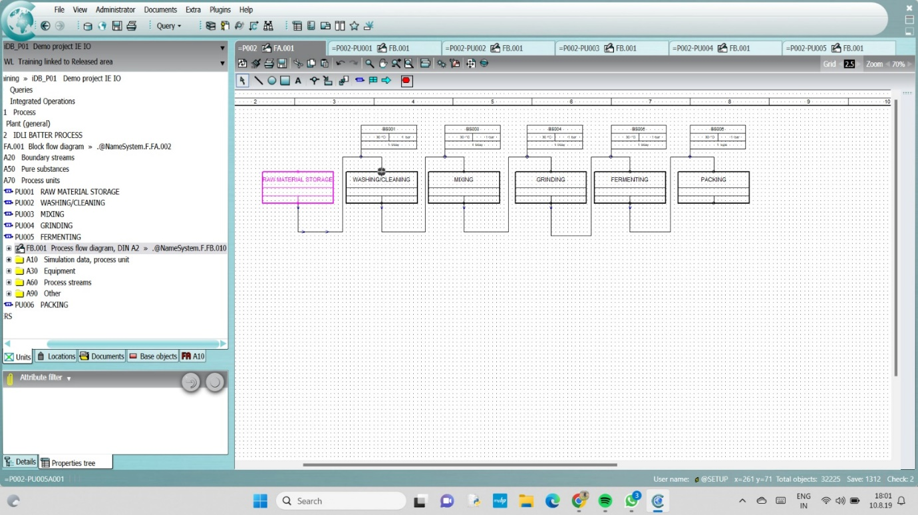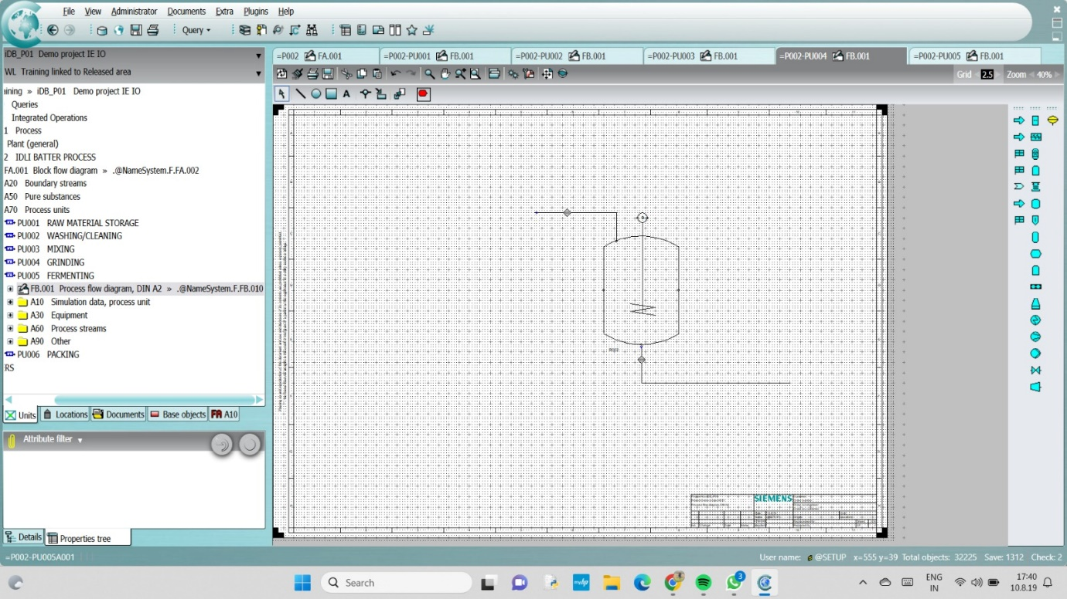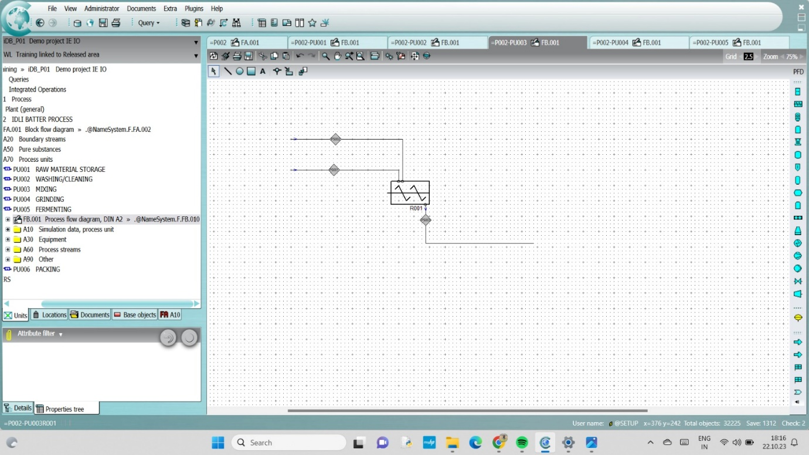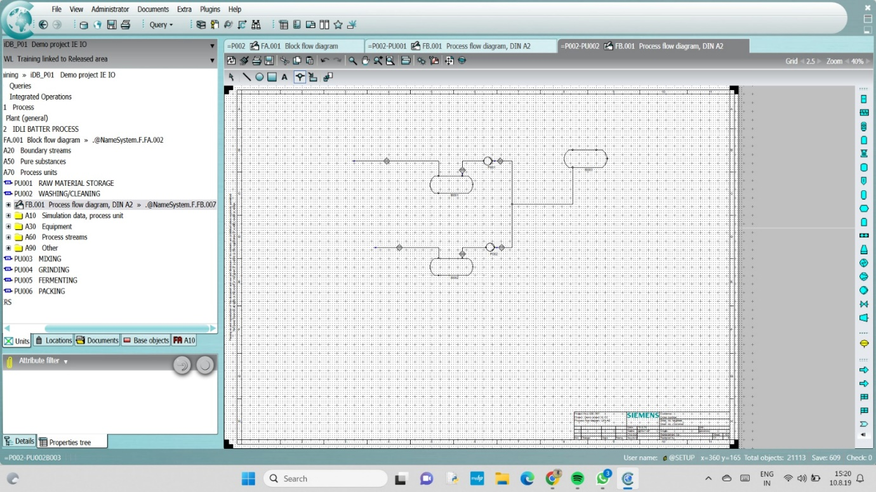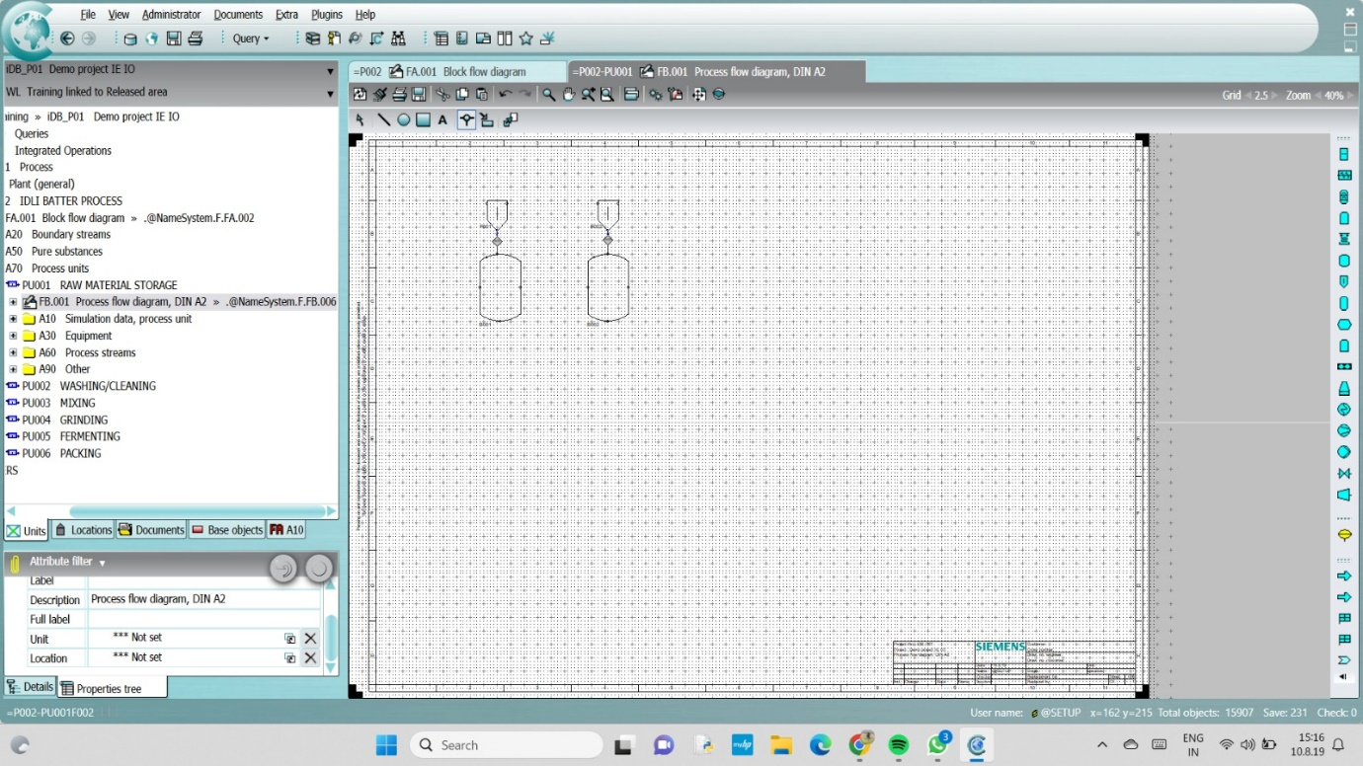

**3 Result and discussion:**

Thus the knowledge and understanding of the PFD and PID are obtained and applied successfully in the COSMOS software.

**4 Advantages and disadvantages:**

**ADVANTAGE:**

* All process equipment and pipes identified by an equipment number and line number respectively
* All valves, control and block valves are indicated with identification number, type and size
* Pumps with suitable code number must be shown
* All control loops and instruments, with an identification number.

**DISADVATAGES:**

* P&ID charts are not completely reliable as they do not contain accurate details
* It is challenging to draw Piping and Instrumentation Diagrams independently, and require a Process Flow Diagram (PFD) as a referral illustration
* Cannot be reused in multiple projects, and a separate Piping and Instrumentation Diagram must be tailored for each company
* Correct symbols and icons must be used while drawing a Piping and Instrumentation Diagram failing to which, the engineers may end up preparing a faulty piece of equipment.

**5. CONCLUSION:**

The capital-intensive O&G industry, which has been operating in a lower-for-longer oil price environment and is facing

a ‘‘big crew change’’, is reforming its traditional business

model and beginning to integrate digital technologies to

address skill gaps and to maximize production and revenue

while reducing HSE risks and capital and operational costs.

Recently, industries such as manufacturing, automotive, aviation, and healthcare have demonstrated the benefits that may

be achieved using DT technology. O&G operators, oil-field

service companies and other stakeholders are also considering the role of DT technology in the O&G industry. DTs are

virtual replicas of physical assets based on cyber-physical

integration to collect, analyze, and visualize data in order

to make more informed decisions and to conduct a series

of ‘‘what-if’’ scenario analysis to enhance safety, revenue

and production. Critical components of DTs are not new to

the O&G industry which has been collecting, modelling and

simulating data for decades. Most traditional data collection

and use by the O&G industry, however, does not cover the

entire spectrum of DT